Independent Review Report, Reviewer 3
EVALUATION
In their primary research article entitled, “Investigating the Variability in Pressure-Volume Relationships during Hemorrhage and Aortic Occlusion”, F.U. Mobin et al describe a novel method to quantify the time-dependent variance in the left ventricular pressure volume relationship, i.e. PV loops, during hemorrhage and REBOA or EVAC intervention. The present a new Python algorithm which is capable of handling differences in heart rate, a common occurrence during hemorrhage, and demonstrate high degrees of variability in cardiac output, and systolic pressure following REBOA which are less evident with EVAC and thus support the use of partial aortic occlusion with EVAC for the management of acute non-compressible hemorrhage. Overall, the paper is clearly written, easy to follow, and of considerable interest to the field. However, the discussion of variance, use of IVCO, and modelling need to be clarified. See comments below.
Major Questions:

- For the determination of ESPVR and EDPVR the authors should describe how Vo and D determined.
We refer the reviewer to Section 2.3.3, where we explain that V₀ is obtained from fitting a best fit line (i.e., linear regression); V₀ refers to the volume at zero pressure (volume-axis intercept), which we determine using our “end of hemorrhage” (i.e., T30) data. Once V₀ is determined for each animal, we constrain the remaining linear fits with that unique V₀ such that we preserve the physiologic relevance of the ESPVR. In regard to EDPVR, D is a constant obtained via the cubic fit (i.e., polynomial) and represents the pressure-axis intercept (i.e., y-intercept, meaning when volume=0). Given that we do not observe significant differences in EDPVR over the entire experiment, we have removed this from Table 1 and included it as a Supplemental Table 2. We have referenced key seminal papers (see references 39, 40, 41 and 42 in the revised manuscript, also provided below) that further describe the fundamental principles of ESPVR and EDPVR.

References:
Burkhoff D, Mirsky I, Suga HJAJoP-H, Physiology C. Assessment of Systolic and Diastolic Ventricular Properties Via Pressure-Volume Analysis: A Guide for Clinical, Translational, and Basic Researchers. (2005) 289(2):H501-H12.

Claessens TE, Georgakopoulos D, Afanasyeva M, Vermeersch SJ, Millar HD, Stergiopulos N, et al. Nonlinear Isochrones in Murine Left Ventricular Pressure-Volume Loops: How Well Does the Time-Varying Elastance Concept Hold? (2006) 290(4):H1474-H83.

Lankhaar J-W, Rövekamp FA, Steendijk P, Faes TJ, Westerhof BE, Kind T, et al. Modeling the Instantaneous Pressure–Volume Relation of the Left Ventricle: A Comparison of Six Models. (2009) 37(9):1710-26.

Sagawa K, Suga H, Shoukas AA, Bakalar KMJTAjoc. End-Systolic Pressure/Volume Ratio: A New Index of Ventricular Contractility. (1977) 40(5):748-53.

- IVCO is described as a method to determine “preload independent metrics of cardiac performance” with it is a common way to leverage decreasing preload and measure ESPVR. The authors do not show work loops during the IVCO period or assess ESPVR this way and compare to their model. Why not?

While we did not directly show a P-V loop during IVCO vs. pre- and post- we do report the pressure, volume and other cardiac metrics during IVCO in comparison to non-IVCO periods. In addition, the ensemble averaged PV loops from Figure 7 are during IVCO, as these were used to determine ESPVR. To illustrate, the difference between pre-IVCO, during-IVCO and post-IVCO PV loops, we have revised Supplemental Figure 3 to include the pre- and post-IVCO time points. This shift in PV loop is consistent regardless of experimental time point.

- Figure 3/4 – asterisks and crosses indicate significance? What comparisons and degree of significance should be indicated in the figure legend. The authors should determine differences for each group between times (t0-30, t30-74, and t-0-74) as well as between group at each time.
We thank the reviewer and have updated all the figure captions to include this important detail regarding the statistical significance reported. For your reference, red asterisks (*) represent statistically significant differences between time (where T0 is the referent time), significant effects between groups are illustrated with green psi symbol (Ψ) (where the control group is the referent group), and the diamond shaped crosses are extreme data points from each group.

- Results section: There is much discussion about variability (I assume what is meant here is variance) of results as depends on intervention, yet there is no statistical comparison of variances. Do the authors use an F-test to compare variance of parameters with different interventions? The significance of intervention variability should be included in the manuscript.
We ran ANOVA to test for variances between groups and time. The F-statistic and its corresponding p-value has now been included in the revised manuscript where we saw statistically significant differences in variance. Intervention variability (or more precisely the variability in the animal’s response to the intervention) are observed at T74 and discussed in the manuscript.

- Figure 7 – the model fits for EDPVR are really not convincing. Not sure what this modelling adds to the paper.
We included the ESPVR and EDPVR curve fits to our PV loops in Figure 7 to illustrate the changes during hemorrhage and varying degrees of aortic occlusion. While the reviewer points out that EDPVR does not change remarkably between groups or over time, we did not expect that to change. Rather, we expected ESPVR to change since the intervention often results in hypertensive behavior. Nevertheless, we chose to keep both sets of curve fits for comprehensiveness. We did, however, take this into account and have moved the EDPVR curve fit parameters into Supplemental Table 2.

- IVCO is an established way to accurately determine ESPVR. Does ESPVR determined by IVCO agree with ESPVR determined by the python script (i.e. values in table 1)
Yes, we agree. We want to clarify that ESPVR was determined during IVCO only, consistent with existing literature. The Python script simply aided in obtaining beat-to-beat cardiac parameters (within animals and between experimental groups) that were used to quantify ESPVR and other cardiac parameters.

- It seems like a red flag that the values of ESPVR and EDPVR vary so wildly between control, REBOA, and EVAC at T0 and T30 (i.e., when no device has been placed.)
Statistical significance should be indicated in table 1.
The reviewer raises an interesting point which caused us to re-evaluate our ESPVR curve fits. In the revised manuscript we identified V₀ in a more physiologically relevant manner and obtained much better curve fits (as can be seen in revised Table 1). Now, when comparing E_{es} between groups at baseline, we find that E_{es} is not statistically different between control, REBOA and EVAC animals (p>0.05). However, E_{es} does significantly increase after hemorrhage in all groups and remains elevated in the REBOA and EVAC groups at T74. Control animals at T74 resemble baseline E_{es} behavior. We have updated the results section in the revised manuscript to reflect this update. P-values have been reported in the revised Table 1.

- One interpretation is that the control, EVAC, and REBOA have progressive increases in afterload which leads to the response seen in Figure 7C with ESPVR represented by the line drawn through the ESPs in Figure 7C.
Yes, afterload is increased after EVAC and REBOA, so this is an interesting point and we have added it to the revised Figure7C caption and results section of the manuscript.

- General discussion of results: If something is not statistically significantly different from something else, it isn’t different. If the level of variance hid this difference, then the authors should provide sufficient statistical power (more trials) if they want to make claims about differences.
We have reviewed the manuscript thoroughly and assured that only statistically significant findings are reported as different. However, there are instances where we see strong trends where changes are occurring, and larger sample sizes are needed to determine if there is a significant effect. These noteworthy trends are still considered important to discuss and share.

- Discussion paragraph 1, last sentence: What is meant by “exceeding baseline, or normal conditions”?
We meant to describe that pressure values in REBOA are often higher (and exceed normal pressure ranges). This is also visually apparent in Figure 7C. We have revised the sentence to make it more clear to the reader.

- Discussion paragraph 2: The authors claim parameters vary with animal weight, plots should be provided with regression.
When we ran our multivariable mixed regression models, we adjusted for sex and body weight. In the manuscript we report when body weight was significantly associated with certain cardiac parameters (e.g., arterial elastance and cardiac output) from the multivariable regressions (not the individual scatter plots). Nevertheless, we have provided scatterplots of cardiac output vs. animal body weight as well as arterial elastance (Ea) vs. body weight below. You will observe that Ea remains relatively constant at baseline and at the end of hemorrhage, but the relationship changes at T74 post-REBOA or EVAC intervention. The strongest relationship between the animal’s body weight and the cardiac output is seen at T74.

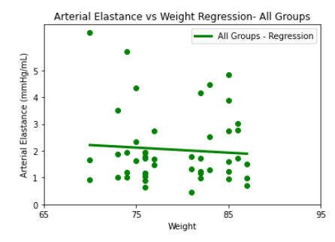 | 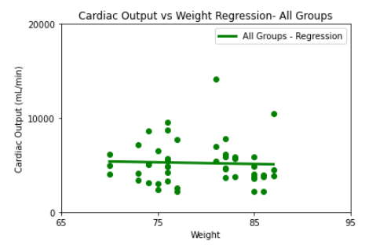
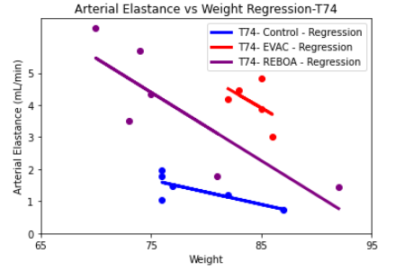 | 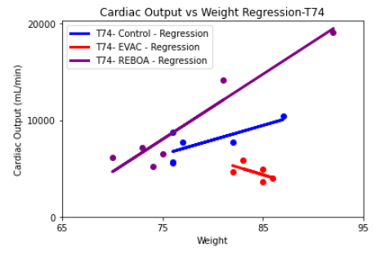

- Discussion paragraph 6-7: As presented the model adds nothing to the paper. The discussion of variability (variance) in the paper is unclear as to the source of the variances and the fits provided by the model are both unconvincing (Figure 7) and seemingly unreliable (table 1 – T0 and T30 data). If the model is a significant portion of this paper, it should be presented in detail and the code should be made available upon publication.
We thank the reviewer and have provided clarifications in the revised manuscript for when we are talking about within group variations vs. individual animal variations. The curve fits have been revised, as previously mentioned and the interpretation of this new data has been included. We believe that this has significantly improved the interpretation and reliability of the presented data. Regarding the code, we are currently discussing options with our innovations office and cannot release it at this time. We do, however, anticipate sharing some form of it in the near future.

- There are numerous abbreviations. An appendix defining abbreviations would be helpful.

This is a great suggestion and we have provided a list of abbreviations used in our supplemental file.

Minor Comments:
Figure S1 legend: “end-isovolumetric contraction (pink)” should be isovolumetric relaxation
Thank you for this typo, we have corrected it.

Suggest use of EF for ejection fraction as this is a more standard abbreviation.
We have revised abbreviation to EF, as suggested.

Not sure why data is tabulated in table 1 rather than box plotted as the other parameters are in this paper. It would be nice to see the progression of the work loops during the IVCO.
Table 1 was provided to ease the reader’s comparison between groups. We have provided the PV loops pre-IVCO, during IVCO- and post-IVCO as a supplemental figure in the revised manuscript.

Discussion paragraph 4. Authors should clarify if they mean beat-beat variability, animal to animal variability or both.
We were able to calculate both beat-to-beat variability, within animal variability and across group variability in our study. We have clarified the language related to variability in the revised discussion. The progression of PV loops during IVCO have been now provided as Supplemental Figure 3.

Discussion paragraph 5: Define MAP.
MAP refers to mean arterial pressure and has been defined in the revised manuscript.

